Lab 11: Advanced Topic in CUDA

Name: Waris Damkham ID: 6388014 Sec: 1

Save your file to “lab10_63xxxxxx.pdf” and upload it to MyCourses website.

**Q1.** Output from “matmul2.cu”

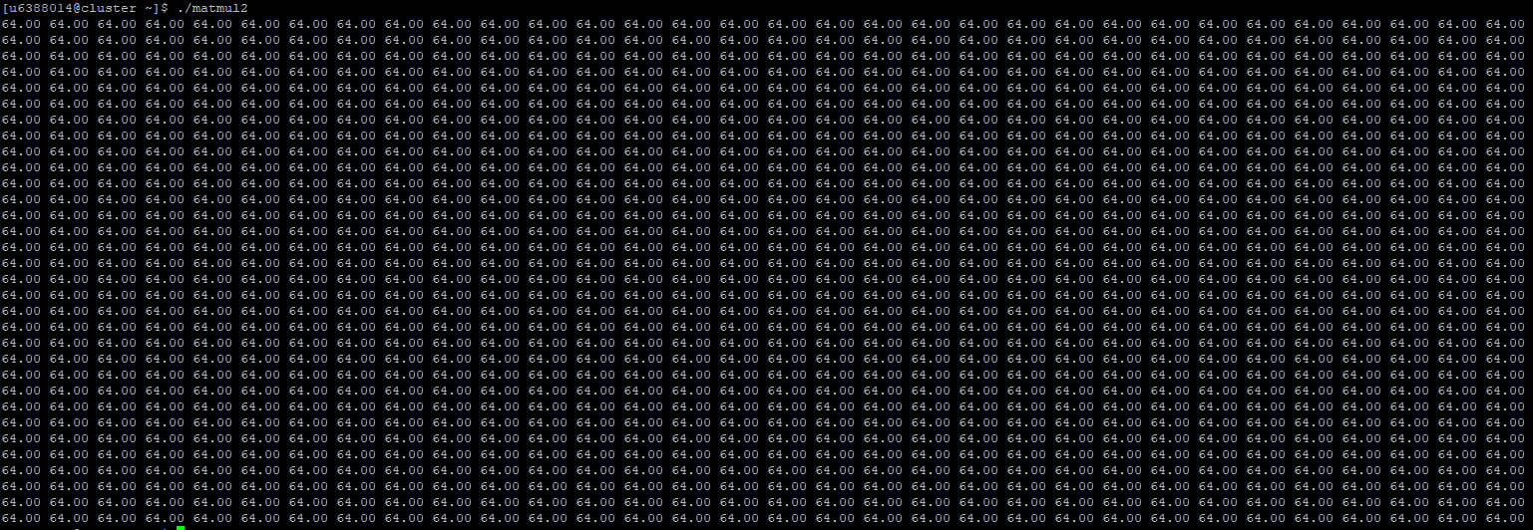

**Q2.** Source code and output from “matmul_shared.cu”

Source code:

Output:

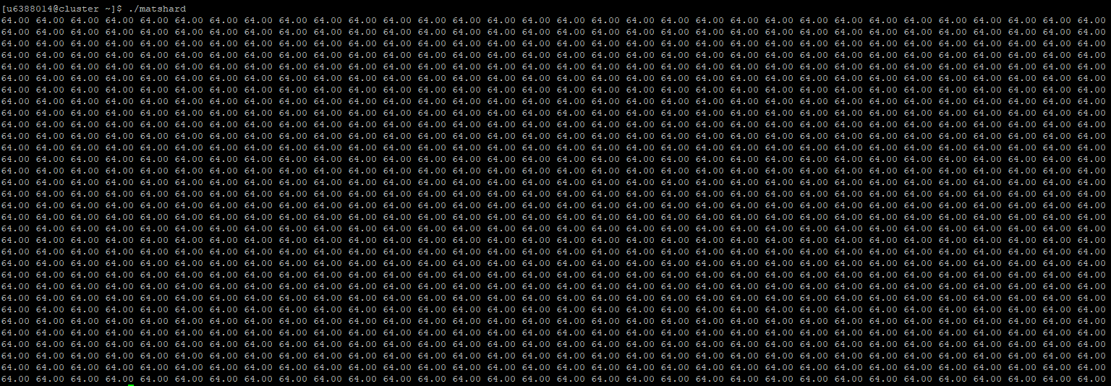

**Q3.** Write down the compiler version.

**Q4.1** Whit is your expected output from “hist.cu”?

Freq 0 = 103

Freq 1 = 103

Freq 2 = 103

Freq 3 = 103

Freq 4 = 103

Freq 5 = 103

Freq 6 = 103

Freq 7 = 103

Freq 8 = 103

Freq 9 = 103

#elements = 1024

**Q4.2** Real output from running “hist.cu”

